Methods to Improve TCP Throughput in Wireless Networks
With High Delay Variability

Kin K. Leung, Thierry E. Klein, Christopher F. Mooney and Mark Haner
Bell Labs, Lucent Technologies
{kin, tek, cfmooney, mh}@lucent.com

Abstract— Highly variable round-trip times (RTTs) in wireless networks can induce spurious timeouts, thus unnecessarily degrading throughput for the Transmission Control Protocol (TCP). In this paper, we propose and study two effective ways to improve TCP throughput in wireless networks. The first technique is to select a retransmission timeout (RTO) threshold higher than that in the de facto standard. Simulation reveals that the proposed method reduces timeouts and provides a relative throughput gain up to 13.7% based on RTT measurements in a commercial 3G network and in a simulated network environment. The second technique is an appropriate use of selective repeat (SR) and go-back-N (GBN) as retransmission policies upon packet timeout. We find that when RTTs have reasonable temporal correlation and packets can arrive out-of-order at the receiver, GBN can improve throughput over the SR policy. Specifically, based on the RTT measurements in the 3G network, our results show that GBN provides a 12% throughput gain over the SR policy.

Keywords – End-to-end performance, split TCP, TCP, timeout, throughput, wireless networks

Introduction
The Transmission Control Protocol (TCP) [1] has been widely used in today’s Internet. The protocol supports reliable data transport by establishing a connection between the transmitting and receiving ends. The transmitter starts a timeout mechanism when sending a packet to the receiver. The transmitter constantly tracks the round-trip times (RTTs) for its packets as a means to determine the appropriate timeout period. At the receiver, each received packet is acknowledged implicitly or explicitly to the transmitter. If the transmitter does not receive an acknowledgment for a given packet when the corresponding timeout period expires, the packet is deemed to be lost and subject to retransmission. A congestion window with dynamically adjusted size is used by the protocol to regulate the traffic flow from the transmitter to the receiver.

Although TCP was initially designed and optimized for wired networks, the growing popularity of wireless data applications has lead third generation wireless networks such as CDMA2000 and UMTS networks to extend TCP to wireless communications as well. The initial objective of TCP was to efficiently use the available bandwidth in the network and to avoid overloading the network (and the resulting packet losses) by appropriately throttling the senders’ transmission rates. Network congestion is deemed to be the underlying reason for packet losses. Consequently, TCP performance is often unsatisfactory when used in wireless networks and requires various improvement techniques [2]. A key factor causing the unsatisfactory performance is that the radio link quality in wireless networks can fluctuate greatly in time due to channel fading and user mobility, leading to a high variability of transmission time and delay. High delay variability is also due to retransmissions at the link level and use of opportunistic schedulers that give preferential service to terminals with good radio links, thus causing additional delay to terminals with relatively poor radio quality. Furthermore, large delay variability can be incurred during handoff from one cell to a neighboring cell. A form of high delay variability, referred to as delay spike, is a sudden, drastic increase in delay for a particular packet or a few consecutive packets, relative to the delay for the preceding and following packets.

When TCP is employed for data transport in such environments, highly variable RTTs and delay spikes can induce spurious timeouts, although the involved packet actually is not lost but simply delayed. Regardless of the actual cause, when a timeout occurs, the TCP congestion window is reduced to 1, thus unnecessarily degrading the throughput.

Many researchers have identified the shortcoming and studied the effects of delay variability on TCP performance in wireless networks. For example, Gurtov [3] observes the impacts of TCP performance due to delay variability. In [4], Fu et al. study performance degradation in the presence of delay spikes for several versions of TCP protocols. Furthermore, various solutions have been proposed to overcome the TCP deficiency for radio links; for example, see [5] for a survey of these proposals. In our view, methods for improving TCP performance in wireless networks can be classified into two groups. The first group of techniques requires new protocol mechanisms or changes to the existing TCP protocols, while the second group of methods are those that do not need new mechanisms or changes.

Among techniques of the first group, Ludwig and Katz [6] propose the TCP Eifel to detect spurious timeouts as well as spurious retransmissions by implementing time stamping (thus the sender can track RTT for every packet). In [7], Gurtov and Ludwig propose further enhancements of TCP Eifel to efficiently respond and avoid spurious timeouts.

The split-TCP solution [1, 8] is a typical method in the second group. This method divides the end-to-end TCP connection between the terminal and the corresponding host into two separate, independent connections with a proxy serving as a common point between the two connections. The key idea behind the split-TCP is to isolate impacts of packet errors and delay variability for the wireless link from the wired connection so that TCP congestion control, timeout and retransmission mechanisms in the wired link do not suffer from the fluctuating quality of the radio channel.

Another enhancement method of the second group is the delay-jitter algorithm proposed and studied in [9, 10]. Since delay variability induces spurious timeouts, one effective way to maintain throughput performance is to absorb the delay variability by a sufficiently large timeout value. The key idea of the delay-jitter algorithm is to increase the TCP timeout value by artificially injecting additional delay to some packets, as a means to adequately increase the mean deviation of the RTTs without much increase in its average. Clearly, the algorithm does not require any modification to the TCP protocol stack.

Despite many existing proposals for TCP improvement in wireless networks, it is not easy to identify a technique that could be viewed as universally suitable for a wide variety of network and application environments. For example, methods of the first group requiring modifications to TCP entities may not readily be adopted because of non-compliance with existing protocol standards. Although the enhancement methods of the second group do not require TCP changes, they suffer from their respective shortcomings. In particular, the split-TCP solution may violate the end-to-end security protection between the transmitter and receiver. In addition, TCP performance for the connection between the terminal and the proxy (which includes a radio link) may not be satisfactory and can be further improved. Finally the delay-jitter algorithm requires appropriate selections of control parameters to minimize the negative performance impacts due to the increase of RTTs.

In this context, it is important to continue our investigation and develop efficient techniques to further improve TCP performance in wireless networks. This is particularly so because such enhancements are badly needed as massive deployment of 3G wireless networks have started and TCP will be commonly used over the radio links. In this paper, we propose and study two effective ways to improve TCP throughput in wireless networks. The first technique is to select a retransmission timeout (RTO) threshold higher than that in the de facto standard. Using RTT measurements in a commercial 3G network and in a simulated network environment, the proposed method reduces timeouts and provides a relative throughput gain up to 13.7%. The second technique is an appropriate use of selective repeat (SR) and go-back-N (GBN) as retransmission policies upon packet timeout. We find that when RTTs have reasonable temporal correlation and packets can arrive out-of-order at the receiver, GBN can improve throughput by 12% over the SR policy, based on the RTT measurements in the 3G network.

The rest of this paper is organized as follows. Section II presents a method using an increased TCP timeout threshold to improve throughput. In Section III, we propose the use of go-back-N as a retransmission strategy to improve throughput performance and compare the relative performance of go-back-N and selective repeat. Simulation results based on actual performance measurements in practical networks are discussed to show the merits of the proposed methods in Section IV. Finally, Section V concludes our paper.

Method of Increased Timeout Threshold
In this section, we begin by discussing the selection of RTO value in standard TCP operations [1]. Then, we present our enhancement method by increased RTO value. A TCP sender constantly tracks the RTTs for its packets and uses a timeout mechanism to trigger retransmissions if an ACK is not received before the timer expires. As a de facto standard, TCP sender uses the tracked average RTT plus m times the mean deviation of RTTs as the RTO value [1] for the next packet where the typical value of the factor m is 4. More precisely, let T(k) denote the k-th measurement value of RTT, where its value is the time interval between the beginning of the packet transmission until an ACK for the packet is received by the sender. Let S(k) be the smoothed average RTT given as:

$$S(k)=(1−α)S(k−1)+αT(k)$$ | (1)
where α is the exponential smoothing parameter with typical value of 1/8. Similarly, we use V(k) to denote the smoothed mean deviation of the RTTs, which is calculated by:

$$V(k)=(1−β)V(k−1)+β|T(k)−S(k)|$$ | (2)
where β is the smoothing parameter, which has a typical value of ¼. Finally, the retransmission timeout (RTO) value is obtained by
$$R(k)=S(k)+mV(k)$$ | (3)
where m is typically set to 4 as a de facto standard.

According to the standard TCP protocol, the TCP sender records the time when it just starts to forward some packet to the receiver. When the sender eventually receives an ACK associated with the packet, the RTT for the packet is thus computed. Using (1) to (3), the smoothed average and mean deviation of the RTTs, and the new RTO value are obtained, respectively. The RTO value is used for setting the timeout period for the next packets sent by the sender, until the next RTT measurement is obtained and the RTO is updated according to the equations. We note that unless the time-stamping option is activated, a TCP sender does not keep track of the RTT for every packet. Instead, only one packet among the outstanding packets is tracked for RTT at any time. As a result, (1) to (3) are invoked to update the RTO value when the ACK for a tracked packet is received by the sender.

We note that setting m to 4 in (3) in determining the RTO value can avoid virtually all spurious timeouts with a probability close to 1, if the RTTs do not demonstrate a high degree of variability, as found in wired network. However, due to reasons such as channel fading, handoff, ARQ retransmissions, packet scheduling and so forth, RTTs in wireless networks tend to have much higher variability than their counterparts in wired networks. For this reason, we propose to use a value larger than 4 for m in computing the RTO threshold value.

Clearly, increasing m in (3) increases the RTO value for the given smoothed average and mean deviation of RTTs. Consequently, a larger RTO value can help absorb the high variability of RTTs in wireless networks, thus avoiding unnecessary spurious timeouts and maintaining throughput performance. On the other hand, the RTO value should not be chosen arbitrarily large to enable speedy recovery of actual packet losses. There is a tradeoff between the throughput gain by avoiding spurious timeouts and the throughput degradation due to the delay in recovering from actual packet losses. While the tradeoff depends on the specifics of the network conditions and parameters, our performance study in Section V shows that for a given packet loss probability, increasing m from the standard value of 4 to 10 yields most of the possible throughput gain. Throughput gain remains relatively constant over a large range of m value (e.g., 10 to 20).

Before continuing, we have a few comments in place. First, although it is natural to increase the RTO value to avoid spurious timeouts in wireless networks, to the best of our knowledge, such a method has not yet been proposed in the literature. This may have been due to the fact that the standard way of calculating the RTO value by (1) to (3) has been widely implemented. It will not be easy, if possible at all, to modify the value of m on existing systems and devices. Nevertheless, our proposed method could be considered in future TCP implementation for wireless applications. Furthermore, if the split-TCP solution is employed in a network, the TCP sender at the proxy server can be modified with the increased m value. For downlink transmissions from the proxy to all its terminals, our proposed method becomes practical even for existing networks, as it requires changing the RTO calculation only on the proxy, without a need to modify the TCP stack on any terminal or server.

Second, it is interesting to contrast this method of increased RTO value with the delay-jitter algorithm [9, 10]. Although the objective of both methods is to avoid spurious timeouts as a means to maintain throughput performance, the jitter algorithm achieves an increased RTO value through injection of extra delay to RTTs, as a means to adequately increase the mean deviation in (3), while the increase of the smoothed average RTT is kept to a minimum. The proposed method in this paper is simply to increase the m value in (3) and thereby achieve the increase in RTO.

There are pros and cons for both the delay-jitter algorithm and the proposed method of increasing the m value. As a key advantage, the jitter algorithm does not require any change to the TCP entity. However, injecting extra delay along the communication path inevitably increases the average RTT. Since the throughput for long-lived TCP flows is roughly inversely proportional to the average RTT, increasing the RTT results in a lower throughput. On the other hand, the increased mean deviation for RTT helps reduce the timeout frequency. Thus, the net performance gain for the delay-jitter algorithm is the resulting tradeoff between throughput loss due to increase of RTT and gain due to avoidance of timeouts. Such a tradeoff does not apply to the proposed method of increasing the m value. Instead, as long as the m value is not excessively large (where the timeout will take a long time to occur in case of actual packet loss), the proposed method will mainly provide throughput gain. On the negative side, the new method requires a modification of the TCP entity.

Method of Go-Back-N Retransmissions
Typically, TCP uses selective repeat (SR) as its retransmission policy in case of timeout [1, 11]. That is, when the timeout for an outstanding packet occurs, the TCP sender retransmits only that packet to the receiver. Another well understood policy that is referred to as the go-back-N (GBN) policy [11]. Under the GBN policy, when a timeout occurs, typically on the unacknowledged packet that was sent at the earliest time, the sender resends all unacknowledged packets, including the packet that caused the timeout. Depending on factors such as packet loss characteristics and bandwidth-delay product, either the SR or GBN policies may yield better throughput performance. For example, when packets are lost in a random fashion, the loss of a particular packet does not imply loss of previous or subsequent packets. In that case, the GBN policy will waste bandwidth and incur extra delay to retransmit all outstanding packets, even when one single packet is lost. In this case, the SR policy often performs better than the GBN policy.
On the other hand, there are network scenarios under which the GBN policy can yield better performance than the SR policy. Let us consider the following scenario in a wireless network. Assume that the radio link quality has moderate to strong temporal correlation, such that, if a packet requires a large number of transmissions before successful reception because of poor link quality, the following packets also suffer long delay. As a result, delays experienced by successive packets are correlated. When the timeout for one packet occurs, it is likely that the following packets also timeout, leading to significant TCP throughput degradation. In addition, we assume that, when the TCP transmitter resends a packet, it may take a different path, thus incurring a different delay and possibly arriving at the receiver before the original copy of the same packet does. This phenomenon is referred to as out-of-order arrivals in the following. For such operating environments with correlated packet delays and early arrival of later packets, we propose here to adopt the GBN protocol as the retransmission policy for TCP. Our study in Section V shows noticeable throughput improvement for the GBN over the SR policy.
Specifically, using the GBN policy, when an unacknowledged packet times out, the TCP sender resets timeout periods and resends all outstanding packets, starting from the timeout packet. All other TCP operations such as acknowledgements (ACK), congestion window adjustment, retransmissions due to duplicate ACKs, etc. remain unchanged.
Before continuing, let us comment on the out-of-order arrivals. If various packets from the sender (e.g., connected to a wired network) are forwarded via different paths, they will incur different delays and can possibly arrive out of order at the receiver. Besides this reason, connection handoffs in wireless networks can also result in out-of-order arrivals at the destination. For example, consider that a terminal is downloading (receiving) a large file while the connection is handed off from a base station A to base station B. Base station A may carry some packets that cannot be sent over the poor radio link to the terminal. While these packets are being forwarded from base station A to B via the backhaul network, the TCP sender resends them (after timeout) to base station B. Thus, the second copy of the packets can arrive at the terminal prior to the original copy forwarded from base station A.

Possible Applications of Proposed Methods
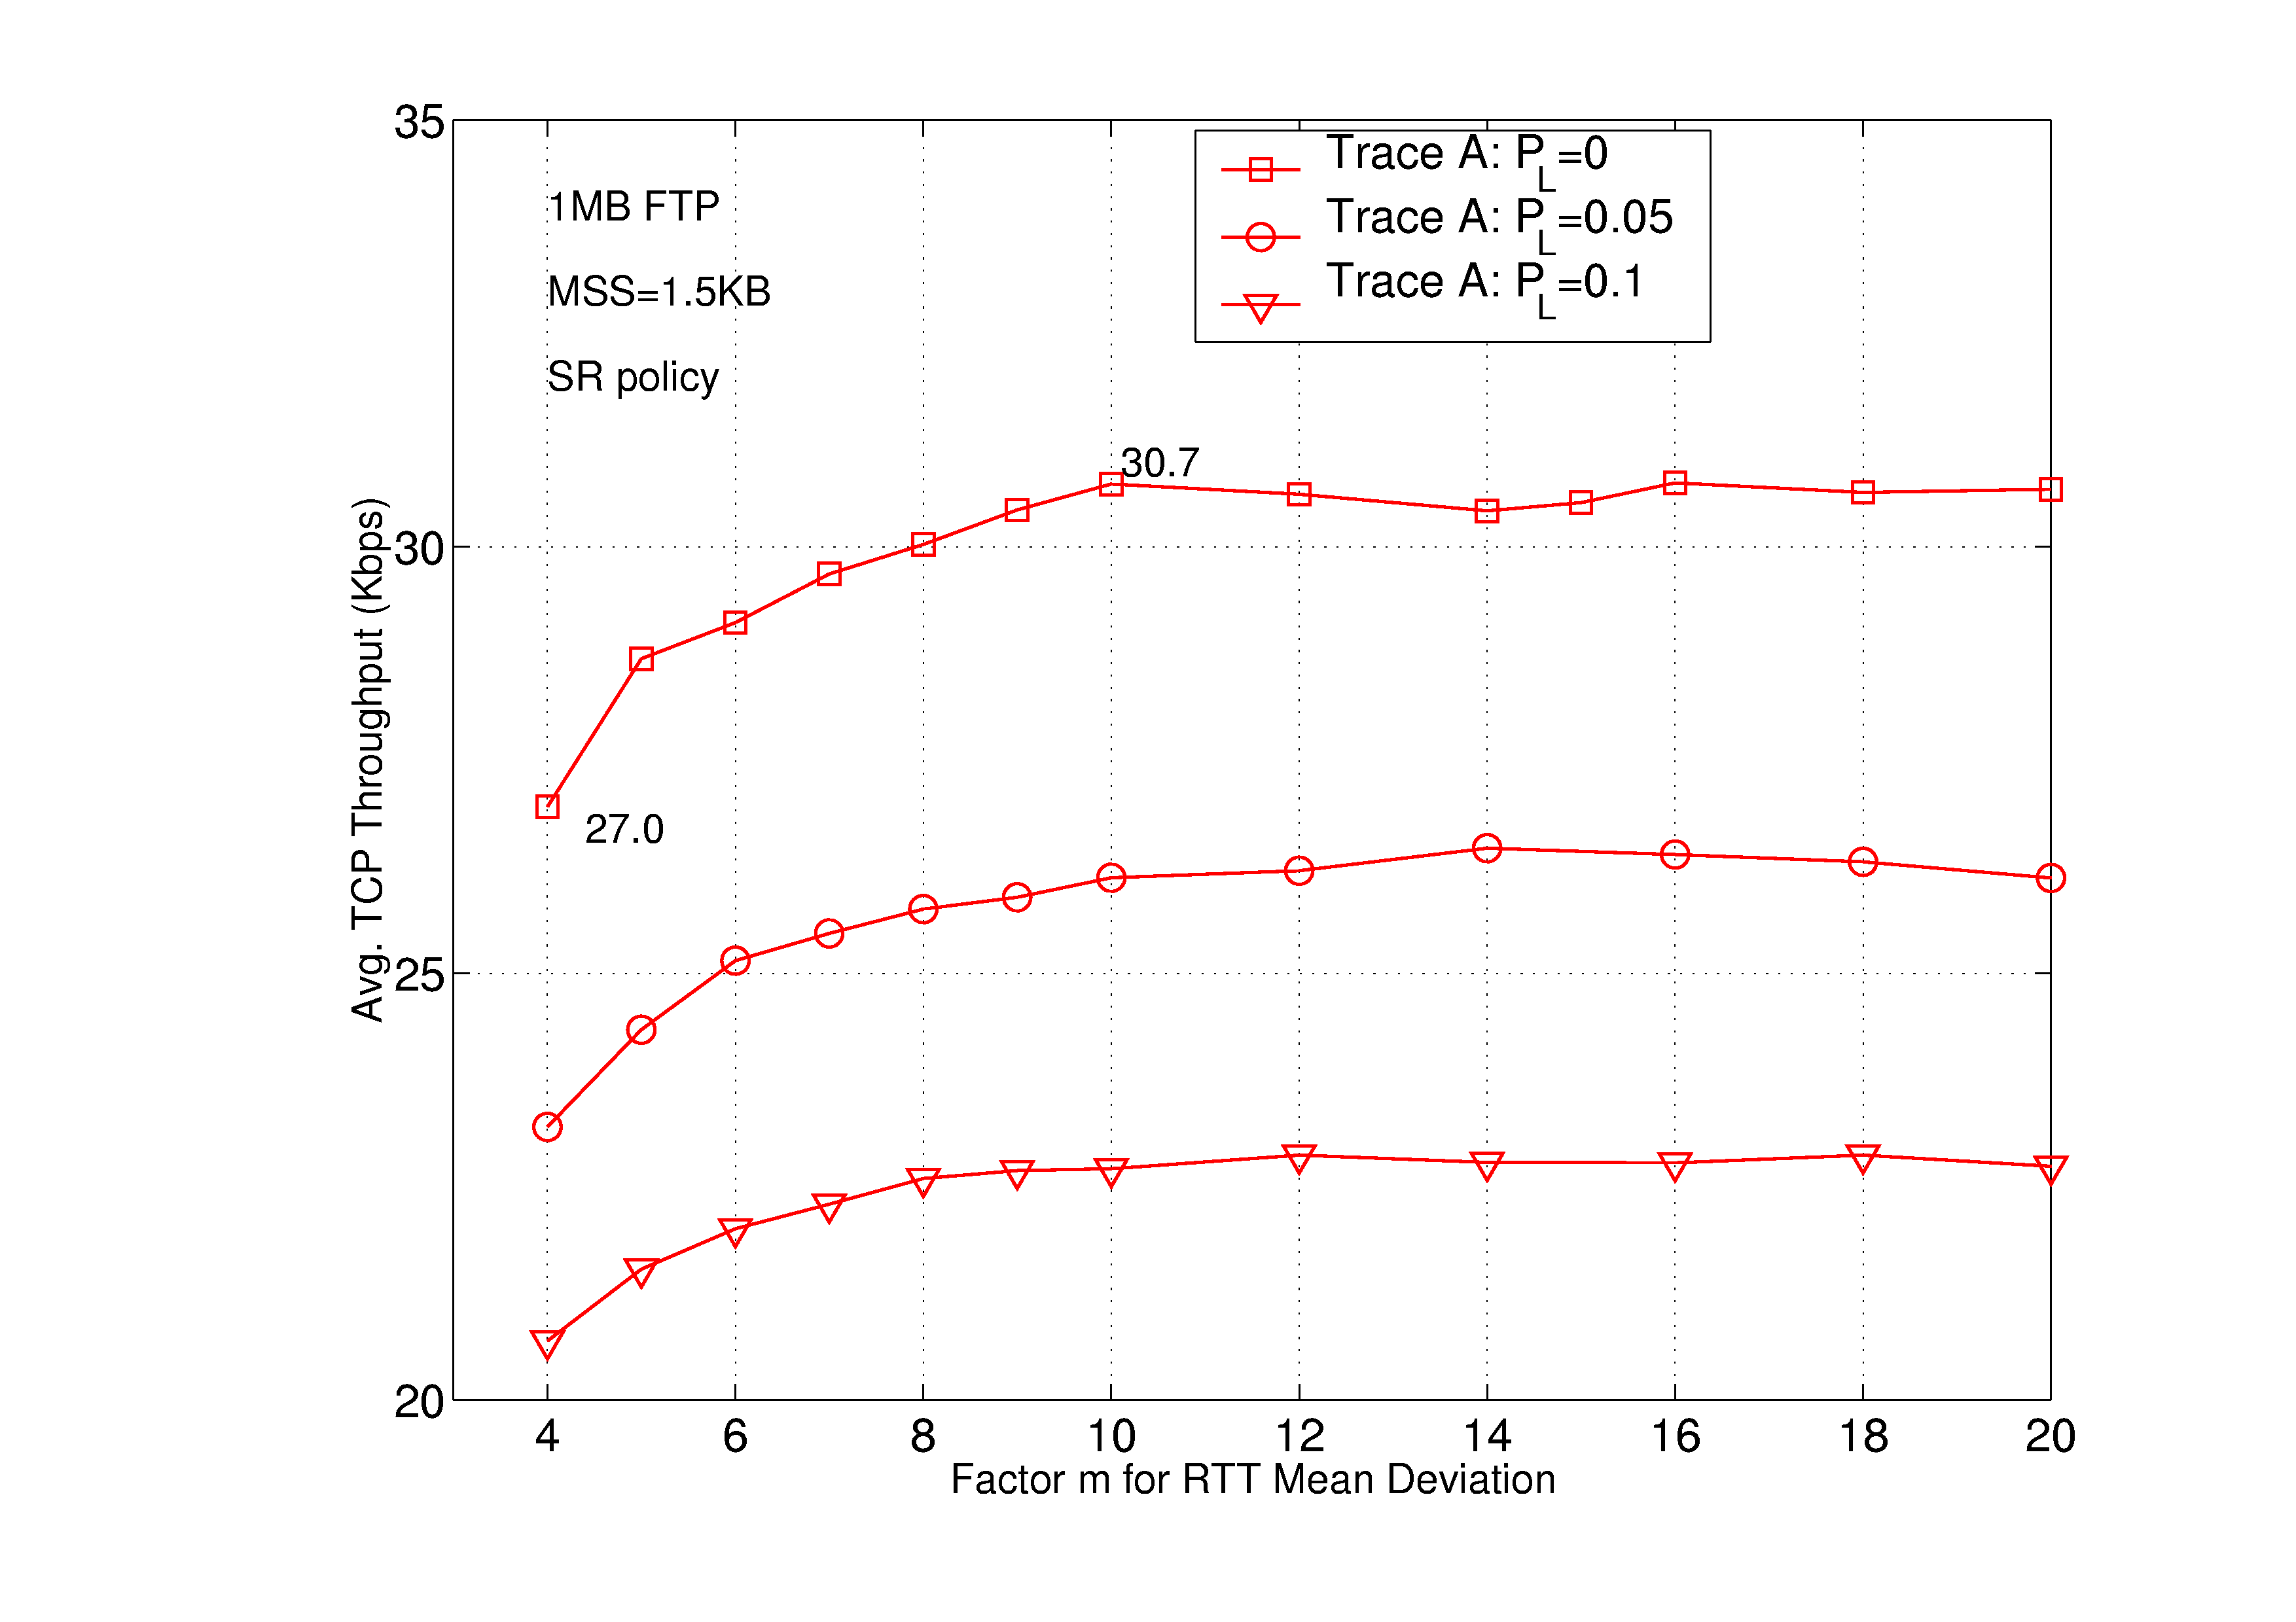
The methods proposed in the last two sections can be applied in future wireless networks in two ways. First, network designers may use increased RTO value in the TCP entity on both base stations and terminals to absorb negative performance impacts of delay variability in wireless networks. Similarly, the GBN policy can be included as an option in the TCP stack, which can be invoked in appropriate operating environments for performance gain. In either case, non-standard-compliant modifications of the TCP entities are required.
Second, the proposed methods can be readily applied in the split-TCP solution discussed earlier. Secifically, for downlink transmissions from the proxy to all its terminals, the proposed methods simply require changing the RTO calculation and/or using the GBN policy on the proxy, without a need to modify the TCP stack on any terminal or server. Changes to the standard TCP operations are required but now only involved a smaller number of entities in the network. The performance gain of the two methods presented in the next section applies to this proxy arrangement.

Performance Study
To study the performance gains of the proposed techniques, we obtain two sets of RTT measurements, which are referred to as Traces A and B. Trace A is a set of measured RTTs by issuing 1.5 Kbyte ping messages one after another from a terminal to a close-by router during a drive test in a commercial 3G network. RTTs in Trace B are generated by simulation of a wireless downlink channel with multiple users. In addition to the distance-based path loss, the channel model also includes shadowing and Rician fast fading using Jakes model to capture the channel fluctuations. The Proportional-Fair (PF) scheduler is implemented to obtain the scheduling delay for transmitting packets of 0.5 Kbyte each on the downlink. The sum of the scheduling delay and a fixed ACK delay on the uplink is treated as the service time for a packet. The RTTs of each trace are then used by a TCP simulator that includes all standard congestion control, acknowledgment processing and packet timeout procedures to quantify the number of timeouts and the throughput for 1 Mbyte file transfers. The simulator uses the exponential-smoothing method to track the average and mean deviation of RTTs [1], as described in equations (1) to (3), but treats the factor m as an input parameter. We also simulate random and independent packet losses at a given probability P_{L}. We emphasize that for Trace A, packets may arrive out of order, whereas for Trace B, due to the first-come first-serve nature of the scheduling algorithm (for packets of the same user) in-sequence delivery of packets and their retransmitted copies is ensured.

Our results reveal that as the factor m and thus the RTO threshold increase, the number of timeout occurrences decreases. Consequently, TCP throughput improves as shown in Fig. 1 for Trace A using the SR policy. As expected, for a given loss probability P_{L}, the throughput first increases as the factor m increases. Then, the throughput reaches a peak at the factor value of 10 to 15. It is interesting to note that the throughput remains relatively flat over a wide range of values for the factor m. With no packet loss, increasing the factor m can improve throughput from 27.0 to 30.7 Kbps, which represents a relative gain of 13.7%. As depicted in the figure, similar gains can be achieved for P_{L} being 5% and 10%.
Figure 1. TCP throughput vs. factor m for Trace A.

In addition, we also obtain about 10% throughput improvement for Trace B in Fig. 2. It is interesting to observe that, with the congestion window generally being larger for Trace B than for Trace A, the throughput for P_{L}=0 is smallest and is increased if P_{L}=5%, uniformly for all considered values of m. This counter-intuitive result is due to the fact that, with actual packet losses, duplicate ACKs are received by the TCP sender to trigger retransmissions before timeouts can occur. The GBN protocol unsuspectingly retransmits packets that have not yet timed out, but might do so in the future. In addition, upon reception of duplicate ACKs, the congestion window is reduced by half, but is not reset to 1 as would be the case under timeout occurrence. There appears to be a packet loss probability that is maximally beneficial and if P_{L} is further increased, e.g to P_{L}=10%, the throughput is again reduced. In any case, these results confirm that using an RTO value higher than the standard one (e.g., using 10 instead of 4 as the factor m) is an effective way to improve TCP performance in wireless networks with high delay variability. In addition, we may also conclude that it may be beneficial to deliberately drop packets in order to trigger duplicate ACKs and thereby avoid spurious timeouts. However determining the appropriate loss probability is a difficult task.
Figure 2. TCP throughput vs. factor m for Trace B.
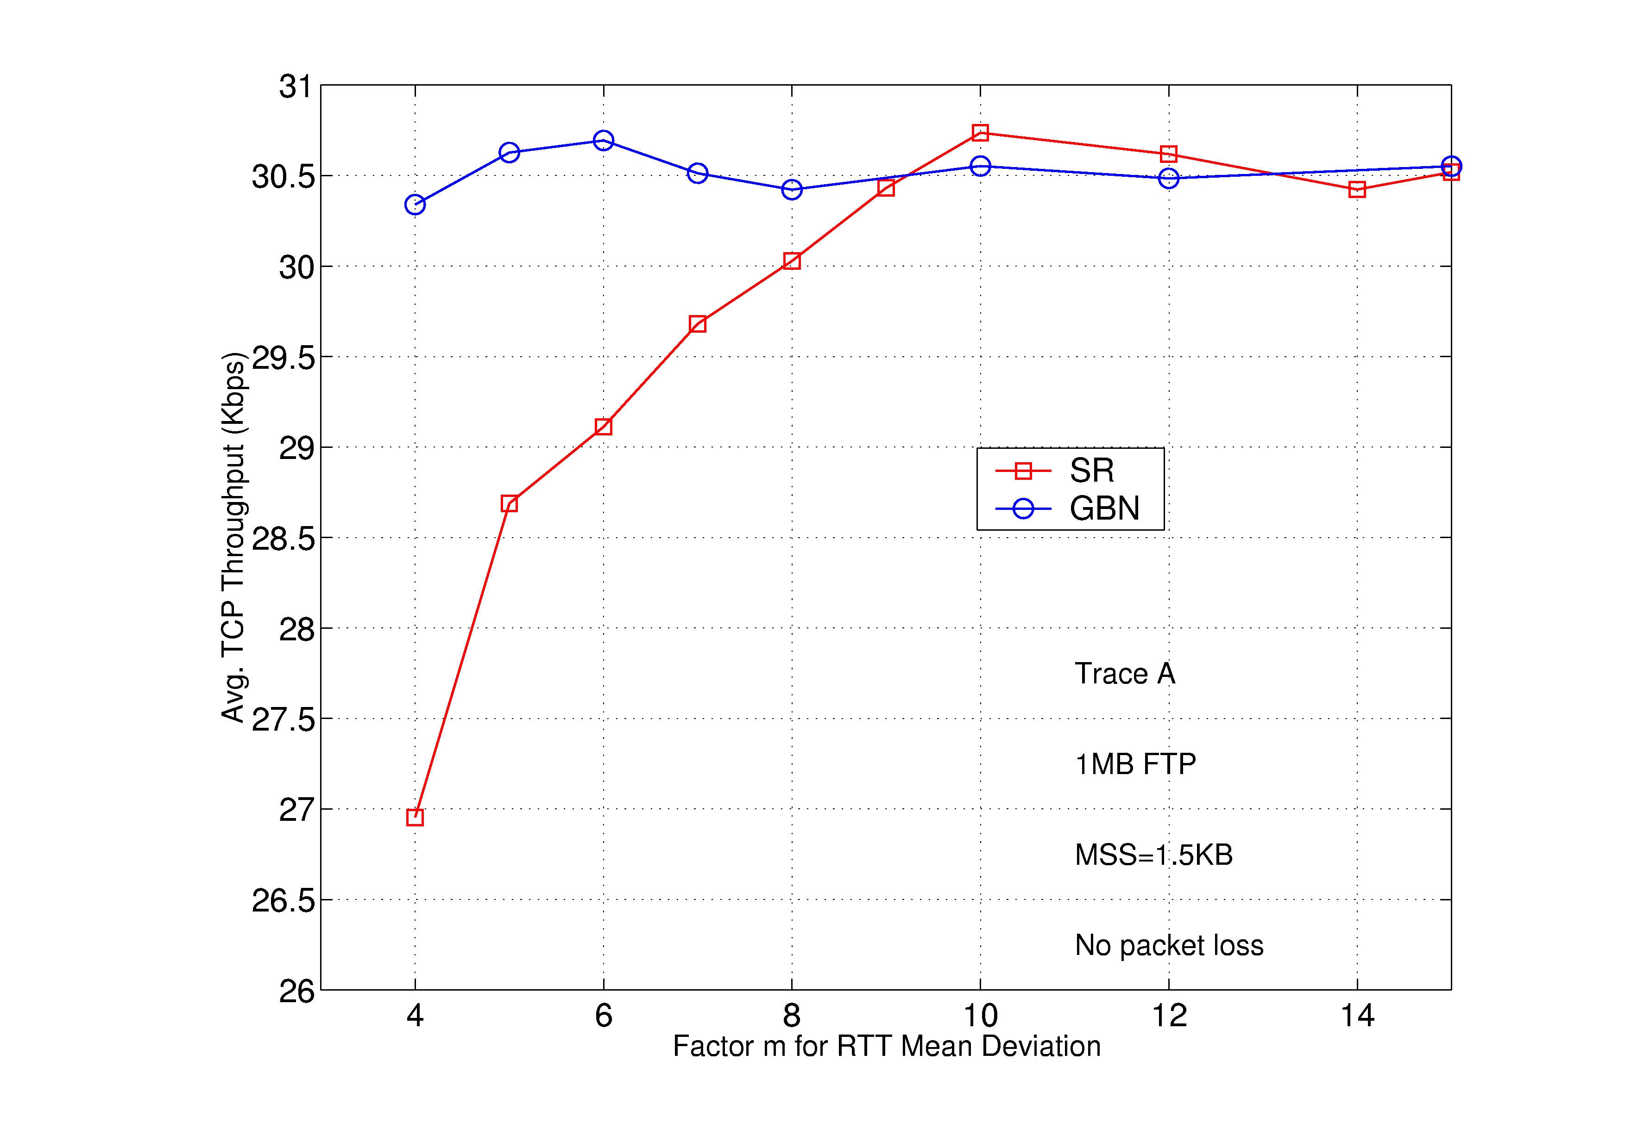
Figure 3. Throughput gain for the GBN over SR policy

Fig. 3 shows that without packet loss, the GBN retransmission policy yields a throughput higher than the SR policy for Trace A, when the factor m is less than 9. The reason for this is explained as follows. RTTs in Trace A have moderate temporal correlation (i.e., an autocorrelation coefficient of 0.42). Thus, when a timeout occurs for a packet, the subsequently sent packets will possibly be timed out as well. Since GBN retransmits packets starting from the timeout packet, timeouts for the subsequent packets are likely to be avoided. In addition, since packets can arrive out-of-order for Trace A, retransmitted packets may reach the receiver earlier than the original transmissions do (if they are not lost), thus maintaining data throughput. As shown in Fig. 3, GBN provides a 12% throughput gain over the SR policy for the factor m equal 4 as in the de facto standard. As spurious timeouts are effectively avoided when the factor exceeds 9, both policies achieve similar throughputs. We also apply the GBN policy to Trace B, in which, except for retransmissions, packets arrive in order at the receiver due to the first-come-first-serve nature of the PF scheduler in Trace B. The SR policy in general gives slightly higher throughput than the GBN policy for Trace B (not shown here). These results reveal that the GBN policy can provide noticeable throughput gain over the SR policy when the RTTs have some degree of temporal correlation and packets can arrive out of order at the receiver.

CONCLUSION
In this paper, we have proposed and investigated the TCP performance under two methods for avoiding or at least reducing the impact of spurious timeouts. The first method is to increase the RTO threshold through an appropriate choice of the factor m. The second method chooses the retransmission policy in a judicious way based on the characteristics of the underlying network (namely the temporal correlations and in-sequence delivery of packets). We have shown significant performance gains for both methods based on simulated and measured RTT traces in commercial 3G networks.

Acknowledgment
The authors would like to thank Gee Rittenhouse for fruitful discussions and his continued support of this research.

References
- W. R. Stevens, TCP/IP Illustrated, Vol. 1: The Protocol, Addison Wesley, New York, 1994.
- H. Balakrishnan, et. al., “A Comarison H. Balakrishnan, et. al., “A Comparison of Mechanisms for Improving TCP Performance Over Wireless Links,” IEEE/ACM Trans. on Networking, Vol. 5, No. 6, Dec. 1997, pp. 756-769.
- A. Gurtov, “Effect of Delays on TCP Performance,” Proc of IFIP Personal Wireless Commun., Aug. 2001.
- S. Fu, et. al., “Effect of Delay Spike on SCTP, TCP Reno and Eifel in a Wireless Mobile Environment,” Proc. of International Conf. on Computer Communications and Networks, Oct. 2002, pp. 575-578.
- H. Elaarag, “Improving TCP Performance over Mobile Networks,” ACM Computing Surveys, Vol. 34, Issue 3, Sept. 2002, pp. 375-374.
- R. Ludwig and R. Katz, “The Eifel Algorithm: Making TCP Robust Against Spurious Retransmissions,” in ACM Computer Communication Review, Vol. 30, No. 1, January, 2000.
- A. Gurtov and R. Ludwig, “Responding to Spurious Timeouts in TCP,” in Proc. of IEEE Infocom, Mar. 2003.
- F. Xie, J. L. Hammond and D. L. Noneaker, “Evaluation of a Split-Connection Mobile Transport Protocol,” Wireless Networks, Vol. 9, 2003, pp. 593-603.
- J. Cloutier et. al., “Improved Wireless Data Transmission Using Time Out Control,” private communication, 2001.
- T. E. Klein, et. al., “Avoiding Spurious TCP Timeouts in Wireless Networks by Delay Injection,” submitted for publication, 2004.
- J. F. Kurose and K. W. Ross, Computer Networking, Addison Wesley, New York, 2001.

